System and Software Architecture Description (SSAD)

The Los Angeles Community Garden Inventory and Locator

Team 13

Ardalan Yousefi | Project Manager
Cole Cecil | Integrated Independent Verification & Validation
Jeff Tonkovich | Implementer
Shi-Xuan Zeng | Tester

April 22, 2012

Version History
Date | Author | Version | Changes made | Rationale
10/06/11 | Ardalan | 0.1 | - Completed section 1 and 2.1. | - Initial draft of SSAD.
10/07/11 | Ardalan, Matt | 0.2 | - Edited section 1.1.  - Completed section 2.2. | - The system analysis models make understanding the proposed system easier and will be later used as a basis for creating class diagrams
10/14/11 | Matt, Ardalan | 0.3 | - Fixed the defects.  - Edited section 2.1.4,and 2.2.  - Corrected the UML diagrams of section 2.1 | - Modified by the IIV&V’s review.  - First draft for section 2.2.  - TA suggested some corrections for the diagrams.
10/16/11 | Ardalan, Matt | 0.4 | - Made a few more corrections to the UML diagrams.  - Fixed the defects found by the IIV&V and the TA. | - A few good points about the SSAD were made by the TA in class.  - Preparing the final version for the ARB meeting.
10/20/11 | Ardalan | 0.5 | - Edited the Artifacts and Info Diagram and added the new artifacts to Table 2. | - The TA thought the different types of users (DB manager and Admin) should be clear in the Artifacts and Info Diagram.
10/23/11 | Matt, Ardalan | 1.0 | - Modified the preconditions of each use case.  - Modified the Artifact & Info Diagram. | - Based on suggestions made during the ARB meeting.
11/20/11 | Matt | 1.1 | - Modified the exception of UC3.  Modified the post conditions of use cases. | - Based on TA’s comment.
11/21/11 | Ardalan, Matt | 1.2 | - Added sections 3 and 4. | - Completed the technology-specific design of the system for Draft DCP.
12/02/11 | Ardalan, Matt | 1.3 | - Update Use Case Diagram and Use Cases.  - Modified the Software component diagram and deployment diagram.  - Updated some class diagrams in section 3.1.2. | - Update for DCP ARB.  - IIV&V’s and the TA’s comments.
12/05/11 | Ardalan | 1.4 | - Add the supported operating systems to the hardware components and deployment diagrams.  - Changed the names of “add/delete column” use cases to “add/delete garden table column” | - Comments from the DCP ARB meeting.
02/05/12 | Ardalan | 2.0 | - Changed the association relationship between control and boundary classes to dependencies. | - TA’s grading comments
02/15/12 | Ardalan | 2.1 | - Added View DB Log, Add and Remove Garden Image, View Garden Picture, and View Driving Directions use cases.  - Added Log File and Garden Image Profile to the Artifacts & Info Diagram. | - comments from RDCR ARB meeting.
03/23/12 | Ardalan | 3.0 | - Updated a couple of process descriptions.  - Added a new use case “Search Garden Table”. | - the bugs found by IIV&V.
03/26/12 | Ardalan, Gary | 3.1 | - Modified the actors description.  - Updated almost every part of section 3. | - The architecture and the implementation need to be consistent with each other.
04/14/12 | Ardalan | 3.2 | - Added the new actor, database manager.  - Modified several UML diagrams and tables. | - New requirement added by the client during the CCD.
04/22/12 | Ardalan | 3.3 | - Modified section 4.  - Modified Internal Report Generation Class Diagram. | - TA’s feedback from code-design review session.

Table of Contents
System and Software Architecture Description (SSAD) i
Version History ii
Table of Contents iv
Table of Tables v
Table of Figures viii
1. Introduction 1
1.1 Purpose of the SSAD 1
1.2 Status of the SSAD 1
2. System Analysis 2
2.1 System Analysis Overview 2
2.2 System Analysis Rationale 25
3. Technology-Specific System Design 26
3.1 Design Overview 26
3.2 Design Rationale 42
4. Architectural Styles, Patterns and Frameworks 43

Table of Tables
Table 1: Actors Summary 2
Table 2: Artifacts and Information Summary 3
Table 3: Process Description - Login 5
Table 4: Typical Course of Action – Login: Successful 6
Table 5: Alternate Course of Action – Login: Failure 6
Table 6: Process Description - Logout 6
Table 7: Typical Course of Action – Logout 6
Table 8: Exception Course of Action – Logout 7
Table 9: Process Description – Search Map 7
Table 10: Typical Course of Action – Search map: Valid Address 7
Table 11: Alternate Course of Action – Search map: Invalid Address 8
Table 12: Exception Course of Action – Search map: Google Maps is not available 8
Table 13: Process Description – View all Gardens 9
Table 14: Typical Course of Action – View all Gardens 9
Table 15: Process Description – View Garden Details 9
Table 16: Typical Course of Action – View Garden Details: From Map 10
Table 17: Process Description – Download Report 10
Table 18: Typical Course of Action – Download Report 10
Table 19: Process Description – View Driving Directions 11
Table 20: Typical Course of Action – View Driving Directions: Valid Address 11
Table 21: Alternate Course of Action – View Driving Directions: Invalid Address 11
Table 22: Exception Course of Action – View Driving Directions: Google Maps is not available 12
Table 23: Process Description – Search Garden Table 12
Table 24: Typical Course of Action – Search Garden List 12
Table 25: Alternate Course of Action – Search Garden List: keyword(s) not found in table 12
Table 26: Process Description – Add Garden 13
Table 27: Typical Course of Action – Add Garden 13
Table 28: Alternate Course of Action – Add Garden 13
Table 29: Process Description – Delete Garden 14
Table 30: Typical Course of Action – Delete Garden 14
Table 31: Alternate Course of Action – Delete Garden 14
Table 32: Process Description – Modify Garden 15
Table 33: Typical Course of Action – Modify Garden 15
Table 34: Alternate Course of Action – Modify Garden 15
Table 35: Process Description – Export Gardens 16
Table 36: Typical Course of Action – Export Gardens 16
Table 37: Process Description – Add Garden Table Column 16
Table 38: Typical Course of Action – Add Garden Table Column 17
Table 39: Alternate Course of Action – Add Garden Table Column 17
Table 40: Process Description – Delete Garden Table Column 17
Table 41: Typical Course of Action – Delete Garden Table Column 18
Table 42: Process Description – Add Garden Picture 18
Table 43: Typical Course of Action – Add Garden Picture 18
Table 44: Exception Course of Action – Add Garden Picture: URL does not exist 18
Table 45: Process Description – Delete Garden Picture 19
Table 46: Typical Course of Action – Add Garden Picture 19
Table 47: Process Description – View Garden Picture 19
Table 48: Typical Course of Action – View Garden Picture 20
Table 49: Process Description – Search Garden Table 20
Table 50: Typical Course of Action – Search Garden Table 20
Table 51: Alternate Course of Action – Search Garden Table: keyword(s) not found in table 21
Table 52: Process Description – View Database Log 21
Table 53: Typical Course of Action – View Database Log : log file accessible 21
Table 54: Exception Course of Action – View Database Log : log file not accessible 21
Table 55: Process Description – Add Database Manager 22
Table 56: Typical Course of Action – Add Database Manager 22
Table 57: Alternate Course of Action – Add Database Manager 22
Table 58: Process Description – Delete Database Manager 23
Table 59: Typical Course of Action – Delete Database Manager 23
Table 60: Alternate Course of Action – Delete Database Manager 23
Table 61: Process Description – Modify Database Manager 23
Table 62: Typical Course of Action – Modify Database Manager 24
Table 63: Alternate Course of Action – Modify Database Manager 24
Table 64: Hardware Component Description 28
Table 65: Software Component Description 29
Table 66: Interface Class Description 30
Table 67: Garden Locator Class Description 31
Table 68: Garden Management Class Description 33
Table 69: Internal Report Generation Class Description 34
Table 70: User Management Class Description 35
Table 71: Architectural Styles, Patterns, & Framework 43

Table of Figures
Figure 1: System Context Diagram 2
Figure 2: Artifacts and Information Diagram 3
Figure 3: Process Diagram 5
Figure 4: Hardware Component Class Diagram 26
Figure 5: Software Component Class Diagram 27
Figure 6: Deployment Diagram 28
Figure 7: Interface Class Diagram 30
Figure 8: Garden Locator Class Diagram 31
Figure 9: Garden Management Class Diagram 33
Figure 10: Internal Report Generation Class Diagram 34
Figure 11: User Management Class Diagram 35
Figure 12: Search Map Sequence Diagram 37
Figure 13: View All Gardens Sequence Diagram 37
Figure 14: Add Garden Sequence Diagram 37
Figure 15: Delete Garden Sequence Diagram 38
Figure 16: Modify Garden Sequence Diagram 38
Figure 17: Search Garden Table Sequence Diagram 39
Figure 18: External Report Generation Sequence Diagram 39
Figure 19: Internal Report Generation Sequence Diagram 40
Figure 20: Add Database Manager Sequence Diagram 41
Figure 21: Delete Database Manager Sequence Diagram 41
Figure 22: Modify Database Manager Sequence Diagram 42

Introduction

Purpose of the SSAD
The purpose of the SSAD is to document the results of the object-oriented analysis and design of the Los Angeles Community Garden and Locator system. SSAD specifies the architecture of the system using numerous UML diagrams and tables. The implementation should be faithful to this architecture. Furthermore, the SSAD is used by the clients to help understand the structure of the system once the proposed system is delivered.

Status of the SSAD
The status of the SSAD is currently at the Initial Operational Capability Package version 3.3. A note was added to section 4, describing the deviation of the implementation from the architecture design. In addition, another bug which was found during the Code-Review design was fixed.

System Analysis

System Analysis Overview
The main purpose of the Los Angeles Community Garden Inventory and Locator is to provide the public with an up-to-date, easily accessible inventory of all the community gardens in Los Angeles via an online, user-friendly mapping tool. The organizations responsible for maintaining and managing these gardens will be able to update the database and generate reports from the database securely and easily.

System Context
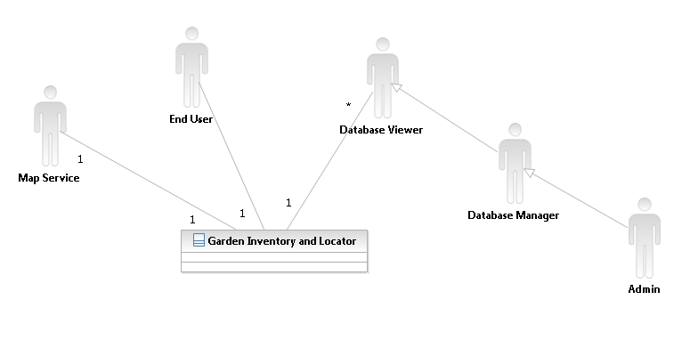
Figure 1: System Context Diagram

Table 1: Actors Summary
Actor | Description | Responsibilities
End User | People who use this system to search information about community gardens. | - Searches gardens and views their information.  - Downloads reports of the gardens.
Database Manager | A member of the four organizations. He/she manages the current data of gardens. | - Updates the data of gardens.  - Generates reports as needed.
Database Viewer | Researchers and other people who want to view all the columns of the garden table, but should not be able to edit the table. | - Views the complete data of gardens.  - Generates reports as needed.
Admin | A member of the four organizations. He/she manages the data managers. | - Updates the list of database managers.  - Updates the data of gardens.  - Generates reports as needed.
Map Service | The online map service used by the Garden Locating System. | - Look for an address.  - Pinpoint an address on the map.  - Display gardens on the map.

Artifacts & Information
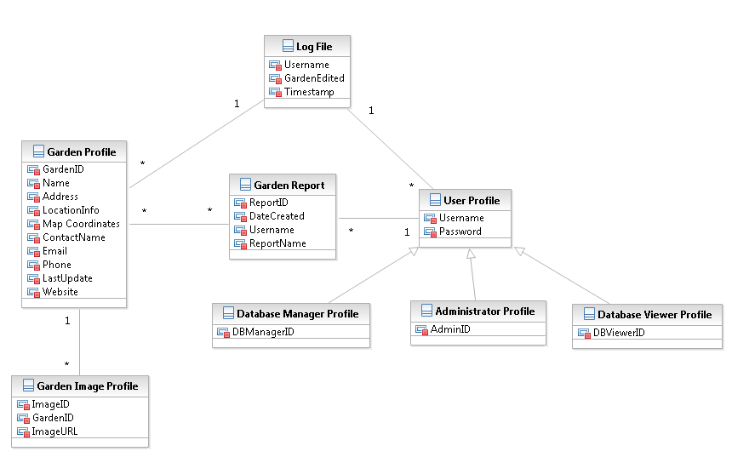
Figure 2: Artifacts and Information Diagram
Table 2: Artifacts and Information Summary
Artifact | Purpose
ATF-1: Garden Report | A report containing the information of all the gardens. Only the database manager can generate this report. The database manager can select what columns appear in the report. The report includes the name of the user generating the report as well as the date it was created.
ATF-2: Garden Profile | Contains the information of the community garden such as the name of the garden, the address, information about its location like on what corner it is or it is next to what shop/restaurant, X and Y coordinates of the garden to be used in the online map, the name, email, and phone number of the person responsible for this garden, the date this information was updated, the URL of the garden’s website, and so forth.
ATF-3: Database Manager Profile | Represents the database managers who can update the database. Only the administrator has access to this list.
ATF-4: User Profile | Includes the username and passwords of all the users who are authorized to work with the database management and report generating modules of the system.
ATF- 5: Administrator Profile | Represents the administrator. The admin is a fixed username and password stored in the database.
ATF-6: Log File | Represents the file that logs the changes made to the database. Stores the name of the user, the name of the garden that was changed, and the time and date of change.
ATF-7: Garden Image Profile | Represents the URL of the images of each Garden.
ATF-8: Database Viewer Profile | Represents the database viewers who have read-only access to the complete garden table. Only the administrator has access to this list.

Behavior
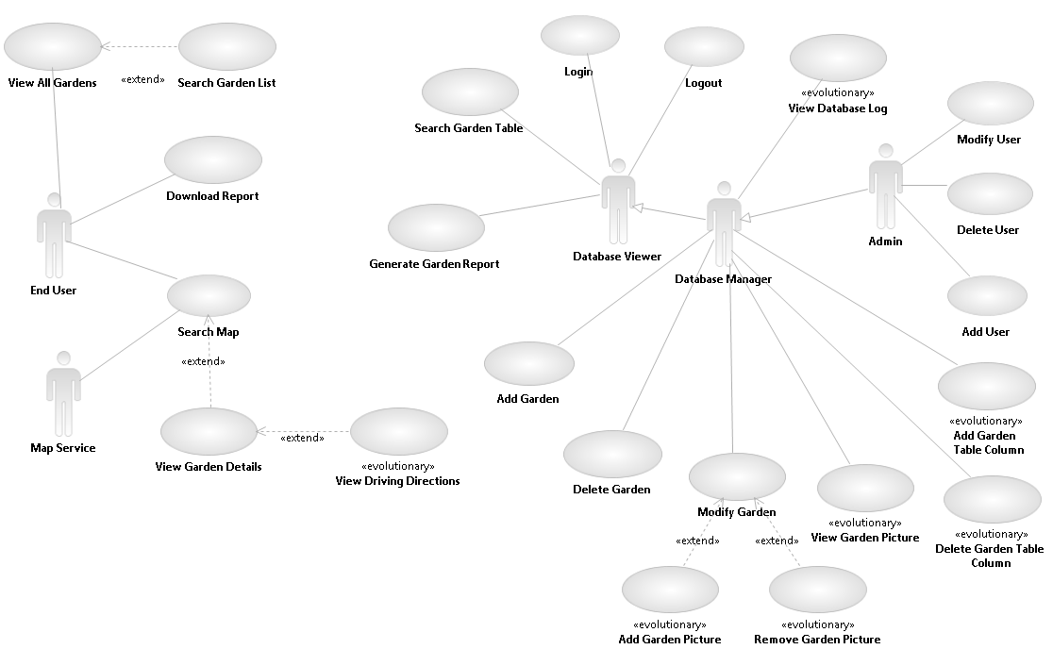Figure 3: Process Diagram

Login/Logout

Login
Table 3: Process Description - Login
Identifier | UC-1 : Login
Purpose | To determine if a person is authenticated when he/she is logging in to the system. If so, it will determine the person as a database manager or admin.
Requirements | CR-3 Login to the System
Development Risks | None
Pre-conditions | System database is properly initialized.
Post-conditions | If a person is authorized, he/she will access to system with appropriate privileges; otherwise, he/she will be denied by the system.

Table 4: Typical Course of Action – Login: Successful
Seq# | Actor’s Action | System’s Response
1 | Enters a user name and password
2 | Clicks Login button
3 |  | Redirects the actor to Database Manager home page.
Table 5: Alternate Course of Action – Login: Failure
Seq# | Actor’s Action | System’s Response
1 | Enters a user name and password
2 | Clicks Login button
3 |  | Displays an error message: ”Username or password is wrong” in a dialog box.
4 | Clicks OK button
5 |  | Redirects the actor to the login page.

Note: Entering only a username, a password, or blanks will be treated the same as entering an invalid username and password.

Logout
Table 6: Process Description - Logout
Identifier | UC-2 : Logout
Purpose | To log out of the system
Requirements | CR-4 Logout of the System
Development Risks | None
Pre-conditions | The user is a database manager or admin.  The user’s login session still exists.
Post-conditions | The user’s login session is terminated.

Table 7: Typical Course of Action – Logout
Seq# | Actor’s Action | System’s Response
1 | Clicks the “log out” hypertext
2 |  | Redirect the actor to the login page.

Alternate Course of Action for Logout is not applicable.
Table 8: Exception Course of Action – Logout
Seq# | Actor’s Action | System’s Response
1 | User tries to directly load logout page
2 |  | Display an error message: “You have not logged in yet.”

Garden Locator

Search Map
Table 9: Process Description – Search Map
Identifier | UC-3 : Search Map
Purpose | To search an address entered by an end-user. If the address exists, the system will show nearby gardens on a map.
Requirements | CR-18 View Public Garden Information Map and CR-19 Search Public Garden Information
Development Risks | None.
Pre-conditions | System database is properly initialized.
Post-conditions | The screen will show the nearby gardens on a map.

Table 10: Typical Course of Action – Search map: Valid Address
Seq# | Actor’s Action | System’s Response
1 | [End User] Enters an address and a radius.
2 | [End User] Clicks on “Find Nearby Gardens” button.
3 |  | Send the address and radius to the map service.
4 | [Map Service] Find the address on the map.
5 | [Map Service] Pinpoint the address on the map and mark the gardens in the radius.
6 | [Map Service] Send the map back to the system.
7 |  | Display the map to the user.

Table 11: Alternate Course of Action – Search map: Invalid Address
Seq# | Actor’s Action | System’s Response
1 | [End User] Enters an address and a radius.
2 | [End User] Clicks “Find Nearby Gardens” button.
3 |  | Send the address and radius to the map service.
4 | [Map Service] Find the address is not existed or invalid.
5 | [Map Service] Report back to the system.
 |  | Display an error message: “The address cannot be found.” in a dialog box.

Table : Alternate Course of Action – Search map: Negative radius
Seq# | Actor’s Action | System’s Response
1 | [End User] Enters an address and a radius.
2 | [End User] Clicks “Find Nearby Gardens” button.
3 |  | Send the address and radius to the map service.
4 | [Map Service] Find the radius is negative.
5 | [Map Service] Report back to the system.
6 |  | Display an error message: “The radius must be greater than zero.” in a dialog box.

Table 12: Exception Course of Action – Search map: Google Maps is not available
Seq# | Actor’s Action | System’s Response
1 | [End User] Enters an address.
2 | [End User] Clicks “Find Nearby Gardens” button.
 |  | Send the address and radius to the map service.
 |  | Display an error message: “Google Maps is not available now.” in a dialog box.

View all gardens
Table 13: Process Description – View all Gardens
Identifier | UC-4 : View all Gardens
Purpose | To provide a list of existing gardens to an end user.
Requirements | CR-17 View Public Garden Information
Development Risks | None
Pre-conditions | System database is properly initialized.  At least one garden exists in the database.
Post-conditions | The end user will be redirected to a page with a list of gardens

Table 14: Typical Course of Action – View all Gardens
Seq# | Actor’s Action | System’s Response
1 | Click the “List of Gardens” hypertext.
2 |  | Redirect the end user to a page with a list of existing gardens.
3 |  | Retrieve the information of all gardens from the database.
4 |  | Display the retrieved info on the list.

Alternate course of action for View All Gardens is not applicable.

Exceptional course of action for View All Gardens is not applicable.

View Garden Details
Table 15: Process Description – View Garden Details
Identifier | UC-5 : View all Garden Details
Purpose | To provide a more detailed information of a specific garden to an end user.
Requirements | CR-20 View Public Garden Information Detail
Development Risks | None.
Pre-conditions | System database is properly initialized.
Post-conditions | Display the detailed information of a specific garden.

Table 16: Typical Course of Action – View Garden Details: From Map
Seq# | Actor’s Action | System’s Response
1 | Click on a garden on the map.
2 |  | Display the detailed information of the garden in a bubble.

Exceptional course of action for search map is not applicable.

Exceptional course of action for search map is not applicable.

Download Report
Table 17: Process Description – Download Report
Identifier | UC-13 : Download Report
Purpose | Download a report file of the gardens in PDF format.
Requirements | CR-21 Download Garden Report for End-Users
Development Risks | None.
Pre-conditions | System database is properly initialized.
Post-conditions | The information of the gardens is saved to a file and passed on as a download link to the end-user.

Table 18: Typical Course of Action – Download Report
Seq# | Actor’s Action | System’s Response
1 | Click “Download PDF” button.
2 |  | Create a report file.
3 |  | Navigate to the report file.

Alternate course of action is not applicable.

Exceptional course of action is not applicable.

View Driving Directions
Table 19: Process Description – View Driving Directions
Identifier | UC-16 : View Driving Directions
Purpose | To view the driving directions from a specific address to one of the gardens.
Requirements | CR-28 View Garden Driving Direction
Development Risks | None.
Pre-conditions | A garden is selected.
Post-conditions | The driving directions will be shown on the map.

Table 20: Typical Course of Action – View Driving Directions: Valid Address
Seq# | Actor’s Action | System’s Response
1 | [End User] Enters a “From” address.
2 | [End User] Clicks on Go button.
3 |  | Send the address to the map service.
4 | [Map Service] Find the address on the map.
5 | [Map Service] Pinpoint the address on the map and show the direction from the garden to the address.
6 | [Map Service] Send the map back to the system.
7 |  | Display the map to the user.

Table 21: Alternate Course of Action – View Driving Directions: Invalid Address
Seq# | Actor’s Action | System’s Response
1 | [End User] Enters a “From” address.
2 | [End User] Clicks Go button.
3 |  | Send the address to the map service.
4 | [Map Service] Cannot find the address.
5 | [Map Service] Report back to the system.
6 |  | Display an error message: “The address cannot be found.” in a dialog box.

Table 22: Exception Course of Action – View Driving Directions: Google Maps is not available
Seq# | Actor’s Action | System’s Response
1 | [End User] Enters an address.
2 | [End User] Clicks Search button.
3 |  | Send the address to the map service.
4 |  | Display an error message: “Google Maps is not available now.” in a dialog box.

Search Garden List
Table 23: Process Description – Search Garden Table
Identifier | UC-22 : Search Garden List
Purpose | Search for particular keywords in the garden list.
Requirements | CR-7 Search Garden Information
Development Risks | None
Pre-conditions | The database is properly initialized.
Post-conditions | The search results, if any, are shown to the end user.

Table 24: Typical Course of Action – Search Garden List
Seq# | Actor’s Action | System’s Response
1 | Enters search keyword(s) in the search box.
2 | Clicks the search button.
3 |  | Looks for the keyword(s) in the entire table.
4 |  | Shows results on the screen.

Table 25: Alternate Course of Action – Search Garden List: keyword(s) not found in table
Seq# | Actor’s Action | System’s Response
1 | Enters search keyword(s) in the search box.
2 | Clicks the search button.
3 |  | Looks for the keyword(s) in the entire table.
4 |  | Shows the message “the keyword(s) you entered did not match any garden.”.

Exceptional course of action is not applicable.

Garden Management

Add Garden

Table 26: Process Description – Add Garden
Identifier | UC-6 : Add Garden
Purpose | Add new gardens to the garden inventory.
Requirements | CR-9 Add Garden Record
Development Risks | None
Pre-conditions | The user has logged in as an administrator or a database manager.
Post-conditions | The garden information is saved to the database.

Table 27: Typical Course of Action – Add Garden
Seq# | Actor’s Action | System’s Response
1 | Enter the appropriate information of garden
2 | Click Add.
3 |  | Validate the entered information.
4 |  | [valid] save the new garden to the database.
5 |  | Display the newly added garden in the list of gardens.

Table 28: Alternate Course of Action – Add Garden
Seq# | Actor’s Action | System’s Response
1 | Enter the appropriate information of garden
2 | Click Add.
3 |  | Validate the entered information.
4 |  | [invalid] Highlight the invalid fields and display a message saying why the entered values are invalid. The fields are still populated.

Exceptional course of action is not applicable.

Delete Garden

Table 29: Process Description – Delete Garden
Identifier | UC-7 : Delete Garden
Purpose | Delete a garden from the garden inventory.
Requirements | CR-11 Delete Garden Record
Development Risks | None
Pre-conditions | The user has logged in as an administrator or a database manager.
Post-conditions | The garden entry is deleted from the database.

Table 30: Typical Course of Action – Delete Garden
Seq# | Actor’s Action | System’s Response
1 | Click Delete on a row which should be deleted.
2 |  | Display a confirmation dialog box.
3 | Click Yes.
4 |  | Delete the row of data from the database.
5 |  | Update the list of gardens to show this change.
Table 31: Alternate Course of Action – Delete Garden
Seq# | Actor’s Action | System’s Response
1 | Click Delete on a row which should be deleted.
2 |  | Display a confirmation dialog box.
3 | Click No.
4 |  | Cancel the action, and display the screen as the same page.

Exceptional course of action is not applicable.

Modify Garden
Table 32: Process Description – Modify Garden
Identifier | UC-8 : Modify Garden
Purpose | Modify and update the information of a garden in the inventory.
Requirements | CR-10 Modify Garden Record
Development Risks | None
Pre-conditions | The user has logged in as an administrator or a database manager.  At least one garden exists in the database.
Post-conditions | The garden information is updated in the database.

Table 33: Typical Course of Action – Modify Garden
Seq# | Actor’s Action | System’s Response
1 | Click the edit button next to a garden row in the list of gardens.
2 |  | Change the fields of that row into text boxes.
3 | Change the information.
4 | Click the update button.
5 |  | Validate the entered information.
6 |  | [valid] Update the garden entry in the database.
7 |  | Update the list of gardens to show this change.

Table 34: Alternate Course of Action – Modify Garden
Seq# | Actor’s Action | System’s Response
1 | Click the edit button next to a garden row in the list of gardens.
2 |  | Change the fields of that row into text boxes.
3 | Change the information.
4 | Click the update button.
5 |  | Validate the entered information.
6 |  | [invalid] Highlight the invalid fields and display a message saying why the entered values are invalid.
7 |  | Display the row only with the valid value.

Exceptional course of action is not applicable.

Generate Garden Report
Table 35: Process Description – Export Gardens
Identifier | UC-9 : Generate Garden Report
Purpose | Export the information of the gardens to a XLSX file.
Requirements | CR-8 Export Garden Information
Development Risks | None.
Pre-conditions | The user has logged in as an administrator, a database manager, or a database viewer.
Post-conditions | The information of the gardens is saved to a file whose link is made available to the admin/DB manager/DB viewer.

Table 36: Typical Course of Action – Export Gardens
Seq# | Actor’s Action | System’s Response
1 | Click Report button.
2 |  | Navigate to the Report page.
3 | Select fields to be included in the report file
4 | Click Generate Report
5 |  | Navigate to the report file.

Alternate course of action is not applicable.

Exceptional course of action is not applicable.

Add Garden Table Column
Table 37: Process Description – Add Garden Table Column
Identifier | UC-14 : Add Garden Table Column
Purpose | Add a new column name to the table of database.
Requirements | CR-12 Add Garden Table Column
Development Risks | None
Pre-conditions | The user has logged in as an administrator or a database manager.
Post-conditions | The new column name is saved to the database.

Table 38: Typical Course of Action – Add Garden Table Column
Seq# | Actor’s Action | System’s Response
1 | Click Add Column button.
2 |  | Navigate to the Add Column page.
3 | Enter the name of the new column, and select the type of column.
4 | Click Add button.
5 |  | Alter table in the database to add a new column.
6 |  | Navigate back to Garden Management Page.

Table 39: Alternate Course of Action – Add Garden Table Column
Seq# | Actor’s Action | System’s Response
1 | Click Add Column button.
2 |  | Navigate to the Add Column page.
3 | Enter a duplicated name of the new column, and select the type of column.
4 | Click Add button.
5 |  | Show a message box with message, “The column name already exists.”
6 | Click OK button.
 |  | Redirect back to Add Column page.

Exceptional course of action is not applicable.

Delete Garden Table Column
Table 40: Process Description – Delete Garden Table Column
Identifier | UC-15 : Delete Garden Table Column
Purpose | Delete a column from the table of database.
Requirements | CR-13 Delete Garden Table Column
Development Risks | None.
Pre-conditions | The user has logged in as an administrator or a database manager.
Post-conditions | The column name is deleted from the database.

Table 41: Typical Course of Action – Delete Garden Table Column
Seq# | Actor’s Action | System’s Response
1 | Click on a checkbox next to a column heading.
1 | Click Delete Column button.
2 |  | Display a confirmation box.
3 | Click Yes.
5 |  | Alter table in the database to delete the column.
6 |  | Refresh the Garden Management Page.

Alternate course of action is not applicable.

Exceptional course of action is not applicable.

Add Garden Picture
Table 42: Process Description – Add Garden Picture
Identifier | UC-17: Add Garden Picture
Purpose | Add the URL of a picture to a garden.
Requirements | CR-25 Add Picture to Garden Record
Development Risks | None.
Pre-conditions | The user has logged in as an administrator or a database manager.  The database is properly initialized.
Post-conditions | The picture URL is stored in the database.

Table 43: Typical Course of Action – Add Garden Picture
Seq# | Actor’s Action | System’s Response
1 | Enter a URL for the picture.
2 | Click “Add Picture”.
3 |  | Check if the URL exists.
4 |  | Add the picture URL to the database.

Alternate course of action is not applicable.

Table 44: Exception Course of Action – Add Garden Picture: URL does not exist
Seq# | Actor’s Action | System’s Response
1 | Enter a URL for the picture.
2 | Click “Add Picture”.
3 |  | Check if the URL exists.
4 |  | Display a “picture does not exist” message.

Delete Garden Picture
Table 45: Process Description – Delete Garden Picture
Identifier | UC-18: Delete Garden Picture
Purpose | Delete the URL of a garden picture.
Requirements | CR-26 Delete Picture from Garden Record
Development Risks | None.
Pre-conditions | The user has logged in as an administrator or a database manager.  The database is properly initialized.
Post-conditions | The picture URL is deleted from the database.

Table 46: Typical Course of Action – Add Garden Picture
Seq# | Actor’s Action | System’s Response
1 | Choose a picture.
2 | Click “Delete Picture”.
3 |  | Display a confirmation box.
4 | Click Yes.
5 |  | Delete the picture’s URL from the database.
6 |  | Display a “picture deleted successfully” message.

Alternate course of action is not applicable.

Exceptional course of action is not applicable.

View Garden Picture
Table 47: Process Description – View Garden Picture
Identifier | UC-19 : View Garden Picture
Purpose | View the pictures of a garden.
Requirements | CR-27 View Pictures of Garden Record
Development Risks | None
Pre-conditions | The user has logged in as an administrator or a database manager.  The database is properly initialized.
Post-conditions | The garden pictures are displayed to the database manager.

Table 48: Typical Course of Action – View Garden Picture
Seq# | Actor’s Action | System’s Response
1 | Clicks the “View Images” button next to a garden name.
2 |  | Navigate to Images web page.
3 |  | Get image URLs from the database.
4 |  | Get images from the URLs.
5 |  | Display images on the web page.

Alternate course of action is not applicable.

Exceptional course of action is not applicable.

Search Garden Table
Table 49: Process Description – Search Garden Table
Identifier | UC-21 : Search Garden Table
Purpose | Search for particular keywords in the garden table.
Requirements | CR-7 Search Garden Information
Development Risks | None
Pre-conditions | The user has logged in as a database manager or a database viewer.  The database is properly initialized.
Post-conditions | The search results, if any, are shown to the user.

Table 50: Typical Course of Action – Search Garden Table
Seq# | Actor’s Action | System’s Response
1 | Enters search keyword(s) in the search box.
2 | Clicks the search button.
3 |  | Looks for the keyword(s) in the entire table.
4 |  | Shows results on the screen.

Table 51: Alternate Course of Action – Search Garden Table: keyword(s) not found in table
Seq# | Actor’s Action | System’s Response
1 | Enters search keyword(s) in the search box.
2 | Clicks the search button.
3 |  | Looks for the keyword(s) in the entire table.
4 |  | Shows the message “the keyword(s) you entered did not match any garden.”.

Exceptional course of action is not applicable.

View Database Log
Table 52: Process Description – View Database Log
Identifier | UC-20 : View Database Log
Purpose | View the log of changes made to the database.
Requirements | CR-24 View Database Log
Development Risks | None
Pre-conditions | The user has logged in as an administrator or a database manager.  The log file is available to be read.
Post-conditions | The contents of the log file is displayed to the database manager.

Table 53: Typical Course of Action – View Database Log : log file accessible
Seq# | Actor’s Action | System’s Response
1 | Clicks the “View Database Log” link.
2 |  | Read from the log File.
3 |  | Display contents on screen.

Alternate course of action is not applicable.

Table 54: Exception Course of Action – View Database Log : log file not accessible
Seq# | Actor’s Action | System’s Response
1 | Clicks the “View Datbase Log” link.
2 |  | Cannot read from the log File.
3 |  | Display “cannot read from log file” message.

User Management

Add Database Manager

Table 55: Process Description – Add Database Manager
Identifier | UC-10 : Add Database Manager
Purpose | Add a new database manager.
Requirements | CR-14 Add User
Development Risks | None
Pre-conditions | The user has logged in as an administrator.
Post-conditions | A new database manager is created in the database.

Table 56: Typical Course of Action – Add Database Manager
Seq# | Actor’s Action | System’s Response
1 | Enters the information of the new user and click “Create Database Manager” button.
2 |  | Validate the entered information.
3 |  | [valid] save the new user to the database.
4 |  | Display the newly added user in the list of Database Managers.

Table 57: Alternate Course of Action – Add Database Manager
Seq# | Actor’s Action | System’s Response
1 | Enters the information of the new user and click “Create Database Manager” button.
2 |  | Validate the entered information.
3 |  | [invalid] Highlight the invalid fields and display a message saying why the entered values are invalid.

Exceptional course of action is not applicable.

Delete Database Manager

Table 58: Process Description – Delete Database Manager
Identifier | UC-11 : Delete Database Manager
Purpose | Delete a database manager.
Requirements | CR-16 Delete User
Development Risks | None
Pre-conditions | The user has logged in as an administrator.
Post-conditions | The database manager is deleted from the database.

Table 59: Typical Course of Action – Delete Database Manager
Seq# | Actor’s Action | System’s Response
1 | Click “Remove” on a row which should be deleted
2 |  | Display a confirmation dialog box.
3 | Click OK.
4 |  | Delete the row of data from the database.
5 |  | Update the list of database managers to show this change.
Table 60: Alternate Course of Action – Delete Database Manager
Seq# | Actor’s Action | System’s Response
1 | Click “Remove” on a row which should be deleted.
2 |  | Display a confirmation dialog box.
3 | Click Cancel.
4 |  | Cancel the action, and display the screen as the same page.

Exceptional course of action is not applicable.

Modify Database Manager
Table 61: Process Description – Modify Database Manager
Identifier | UC-12 : Modify Database Manager
Purpose | Modify a database manager’s password.
Requirements | CR-15 Modify User
Development Risks | None
Pre-conditions | The user has logged in as an administrator.  At least one database manager exists in the database.
Post-conditions | The database manager’s password is updated in the database.

Table 62: Typical Course of Action – Modify Database Manager
Seq# | Actor’s Action | System’s Response
1 | Click the “Change Password” button next to a database manager row in the list of the database managers.
2 |  | Navigate to “change password” page.
3 | Enter new, and confirm passwords.
4 | Click the “Change Password” button.
5 |  | Validate the entered information.
6 |  | [valid] Update the database manager entry in the database.
7 |  | Update the list of database managers to show this change.

Table 63: Alternate Course of Action – Modify Database Manager
Seq# | Actor’s Action | System’s Response
1 | Click the “Change Password” button next to a database manager row in the list of the database managers.
2 |  | Navigate to “change password” page.
3 | Enter new, and confirm passwords.
4 | Click the “Change Password” button.
5 |  | Validate the entered information.
6 |  | [invalid] Highlight the invalid fields and display a message saying why the entered values are invalid.

Exceptional course of action is not applicable.

Modes of Operation
The Los Angeles Community Garden Inventory and Locator works in only one mode of operation.

System Analysis Rationale
Fundamentally, the Los Angeles Community Garden Locator and Inventory is comprised of two subsystems:
- The online garden map system to which the general public have access.
- The database management system to which only database managers and administrators have access.
In addition, based on our analysis of how user interacts with the system as shown in the Behavior section of System Behavior Analysis, four types of users have been identified:
- End User: These users search and view information of gardens from the system. They do not have to login to the system.
- Database Viewer: These users have read-only access to the complete garden table. They can also generate reports from the table.
- Database Manager: These users update the database and generate reports. They have to login to the system in order to do these actions.
- Admin: This admin is authorized to manage the user accounts and passwords. He/She is able to update the database and generate reports, too. The admin also has to login the system in order to do these actions.
There is one external actor interacting with the system.
- Map Service: It helps us to search the nearby gardens and display the search results on the map.

Technology-Specific System Design

Design Overview

System Structure
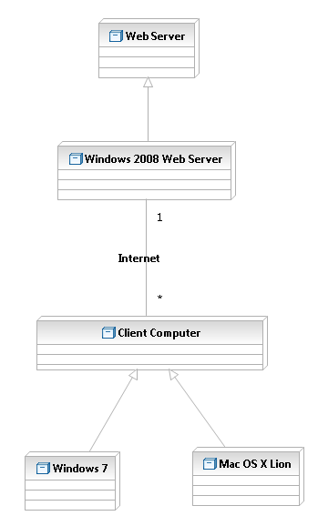
Figure 4: Hardware Component Class Diagram

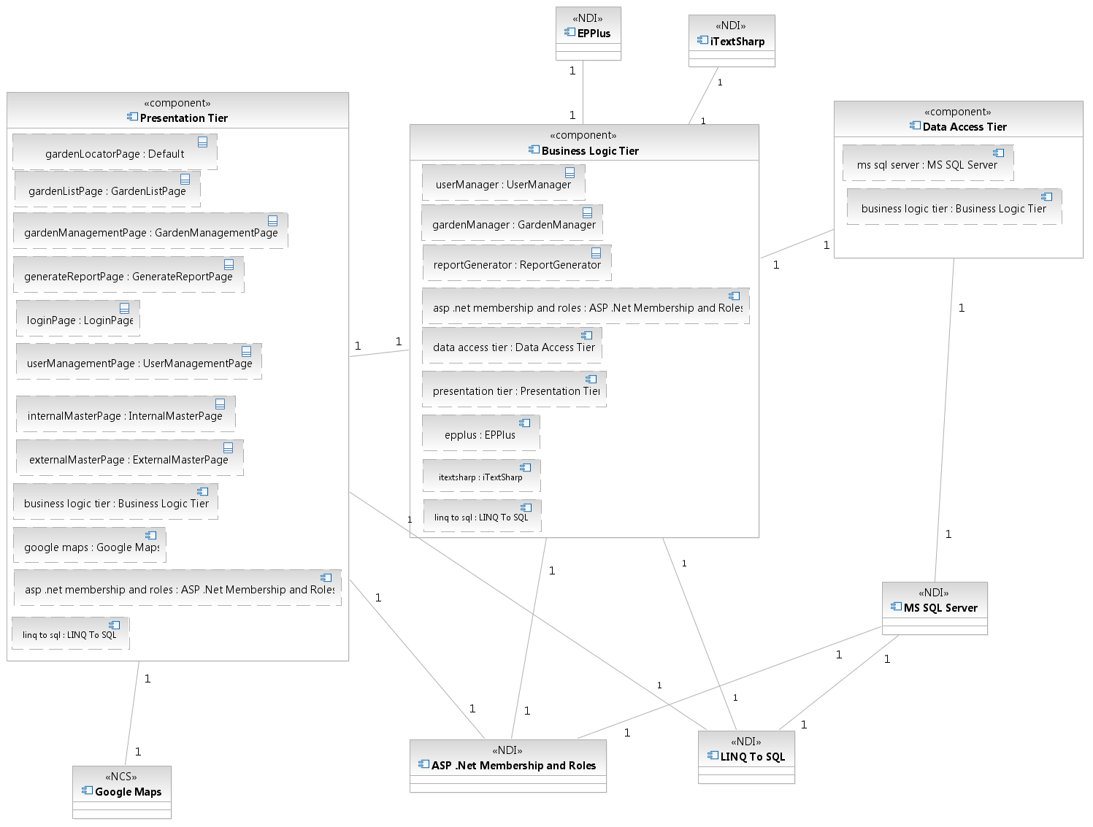
Figure 5: Software Component Class Diagram
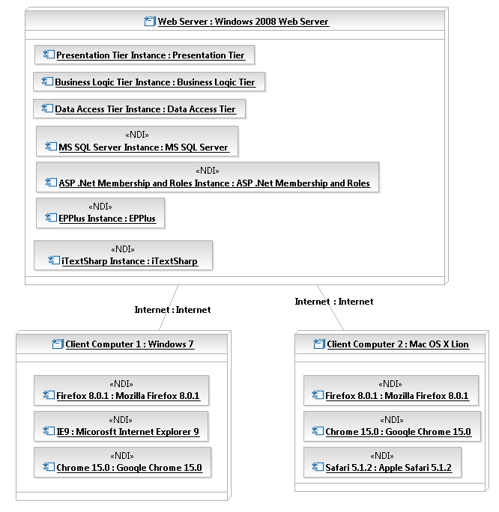
Figure 6: Deployment Diagram
Table 64: Hardware Component Description
Hardware Component | Description
Client Computer | A computer that browses the Garden Inventory and Locator website via the Internet.
Windows 7 | A client computer with Windows 7 as its operating system.
Mac OS X Lion | A client computer with Mac OS X Lion as its operating system.
Web Server | A web server that hosts the Garden Inventory and Locator website.
Windows 2003 Web Server | A web server running on Microsoft Windows Server 2003 that hosts the Garden Inventory and Locator website.

Table 65: Software Component Description
Software Component | Description
Presentation Tier | This component contains all the web pages and their code-behind files.
Business Logic Tier | This component holds all the classes that contain the business logic of the system.
Data Access Tier | This component is comprised of classes that connect to the database and read/write data from/to it.
Google Maps | A web service that is used by the presentation tier to display the gardens on the map of Los Angeles.
ASP .Net Membership and Roles | This component is one of the features of ASP .Net that facilitates authentication, authorization, and user management.
EPPlus | This NDI is used to create reports in excel format from the gardens in the database.
iTextSharp | This NDI is used to create reports in pdf format from the gardens in the database.
MS SQL Server | A DBMS that stores all the information of gardens and users.
LINQ to SQL | A feature of .NET that facilitates connecting to the database and managing the data in the database; eliminates the need to write classes for connecting to the database from scratch.

Design Classes
The design classes describe the relationships among the boundary, control, and entity classes of the Garden Inventory and Locator website.

Interface Classes
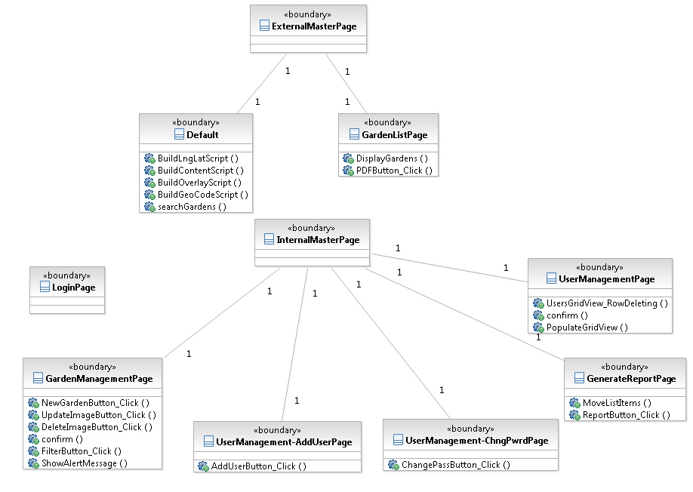

Figure 7: Interface Class Diagram

Table 66: Interface Class Description
Class | Type | Description
ExternalMasterPage | Boundary | A master page that creates a consistent layout for the external section of website.
Default | Boundary | This page enables the end user to search for gardens near an address and shows the results on the Google Maps.
GardenListPage | Boundary | This page shows a list of all the gardens in the database to the end user. In addition, the end user can download a report of gardens in PDF format through this page.
InternalMasterPage | Boundary | A master page that creates a consistent layout for the internal section of website.
LoginPage | Boundary | The database managers and the administrator can login to the system via this page.
GardenManagementPage | Boundary | The database manager can add, delete, or modify a garden through this page.
GenerateReportPage | Boundary | This page lets the database manager select a number of columns and export the information of the gardens to an excel spreadsheet.
UserManagementPage | Boundary | The administrator can manage the database managers using this page.
UserManagement-AddUserPage | Boundary | The administrator can enter the information of a new database manager in this page.
UserManagement-ChngPwdPage | Boundary | The administrator can change the password of a database manager in this page.

Garden Locator Classes
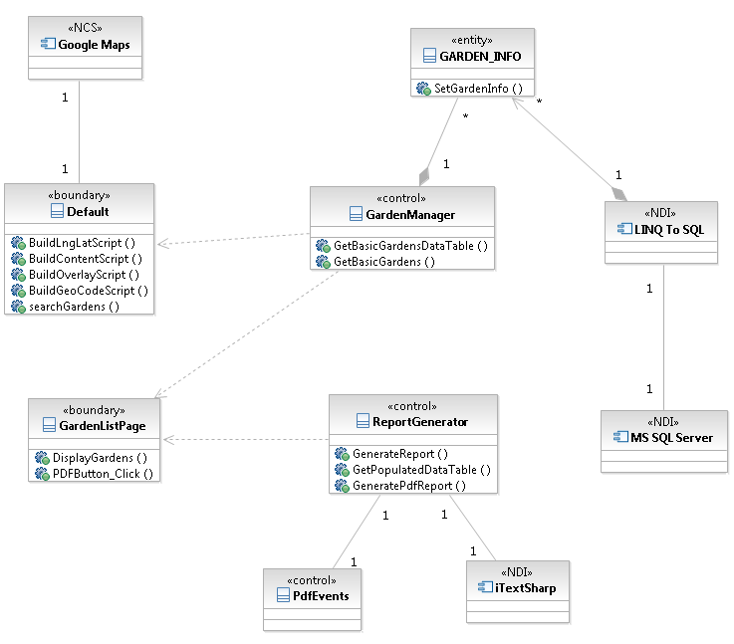
Figure 8: Garden Locator Class Diagram
Table 67: Garden Locator Class Description
Class | Type | Description
GARDEN_INFO | Entity | This class holds the information of a garden. This class is generated by LINQ to SQL.
Default | Boundary | This page enables the end user to search for gardens near an address and shows the results on the Google Maps.
GardenListPage | Boundary | This page lists all the gardens with limited information. In addition, the end user can generate a report of gardens in PDF format through this page.
GardenManager | Control | This class contains the business logic of selecting gardens from the database.
LINQ To SQL | NDI | A feature of .NET that facilitates connecting to the database and managing the data in the database; eliminates the need to write classes for connecting to the database from scratch.
Google Maps | NCS | A web service that is used by the GardenLocatorPage to display the gardens on the map of Los Angeles.
PdfEvents | Control | This class helps the ReportGenerator class to format the header and footer of the PDF file and add pictures to them.

Garden Management Classes
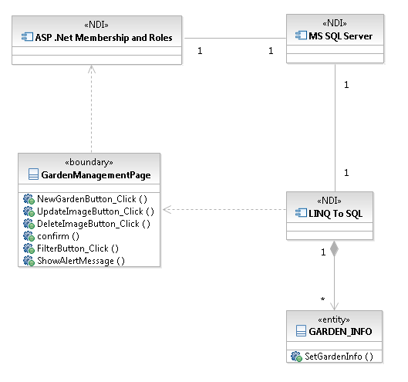
Figure 9: Garden Management Class Diagram
Table 68: Garden Management Class Description
Class | Type | Description
ASP .Net Membership and Roles | NDI | This component checks the user’s authentication and authorization.
GardenManagementPage | Boundary | The database manager can add, delete, or modify a garden through this page.
LINQ To SQL | NDI | A feature of .NET that facilitates connecting to the database and managing the data in the database; eliminates the need to write classes for connecting to the database from scratch.
GARDEN_INFO | Entity | This class holds the information of a garden. This class is generated by LINQ to SQL.
MS SQL Server | NDI | A DBMS that stores all the information of gardens and users.

Internal Report Generation Classes
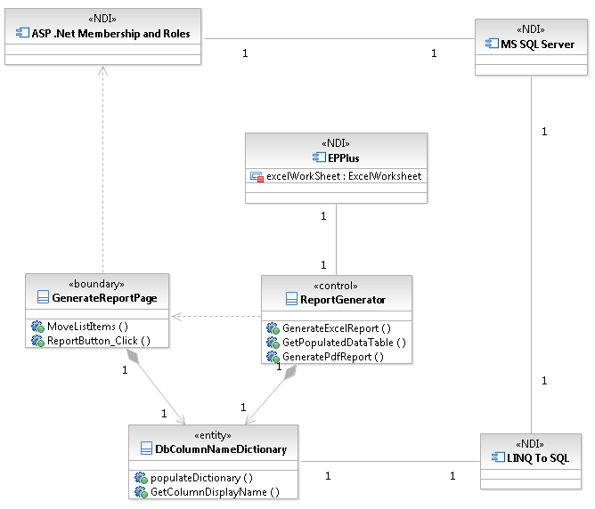
Figure 10: Internal Report Generation Class Diagram
Table 69: Internal Report Generation Class Description
Class | Type | Description
ASP .Net Membership and Roles | NDI | This component checks the user’s authentication and authorization.
GenerateReportPage | Boundary | This page lets the database manager select a number of columns and export the information of the gardens to an excel spreadsheet.
ReportGenerator | Control | This class contains the business logic of generating a report from the gardens in the database.
LINQ To SQL | NDI | A feature of .NET that facilitates connecting to the database and managing the data in the database; eliminates the need to write classes for connecting to the database from scratch.
EPPlus | NDI | This NDI is used to create reports in excel format from the gardens in the database.
MS SQL Server | NDI | A DBMS that stores all the information of gardens and users.
DbColumnNameDictionary | Entity | A class that stores the name of the columns of the garden table in a dictionary.

User Management Classes
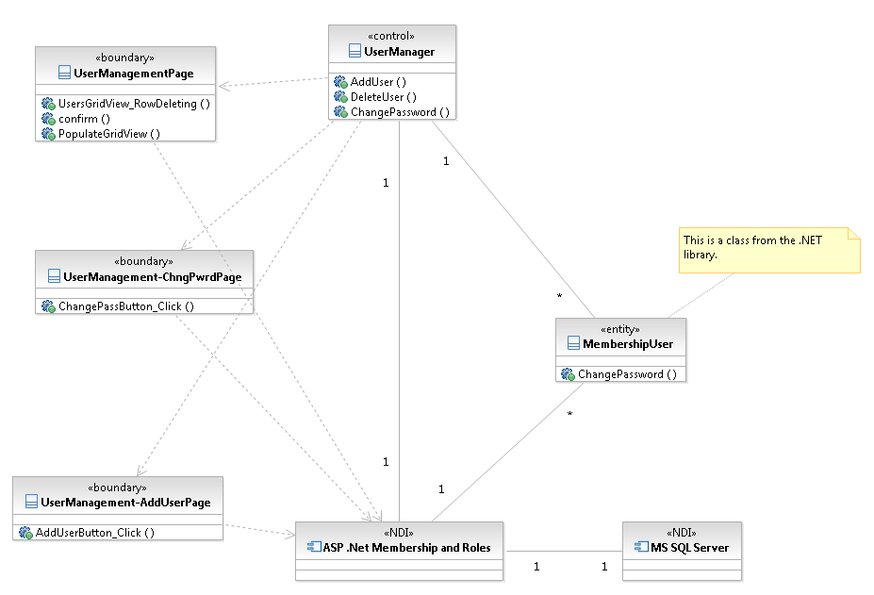
Figure 11: User Management Class Diagram
Table 70: User Management Class Description
Class | Type | Description
ASP .Net Membership and Roles | NDI | This component makes sure that the user is an administrator. In addition, it adds, updates, and deletes database managers.
MembershipUser | Entity | A .NET class holding the information of a user (administrator, database manager, or database viewer).
UserManagementPage | Boundary | The administrator can manage the database managers using this page.
UserManagement-AddUserPage | Boundary | The administrator can enter the information of a new database manager in this page.
UserManagement-ChngPwdPage | Boundary | The administrator can change the password of a database manager in this page.
UserManager | Control | This class contains the business logic of adding, updating, and deleting database managers.
MS SQL Server | NDI | A DBMS that stores all the information of gardens and users.

Process Realization
This section shows how the use cases described in section 2.1.3 are going to be realized using sequence diagrams. All the sequence diagrams can also be found in the RAS file available on the team website.

Since the beginning of the implementation, the team decided to use the LINQ To SQL feature of the .Net framework. This decision led to most of the sequence diagram becoming simpler because LINQ To SQL handles the interactions with the database itself.

The sequence diagram in Figure 12 depicts how the end user can search for gardens using Google Maps.

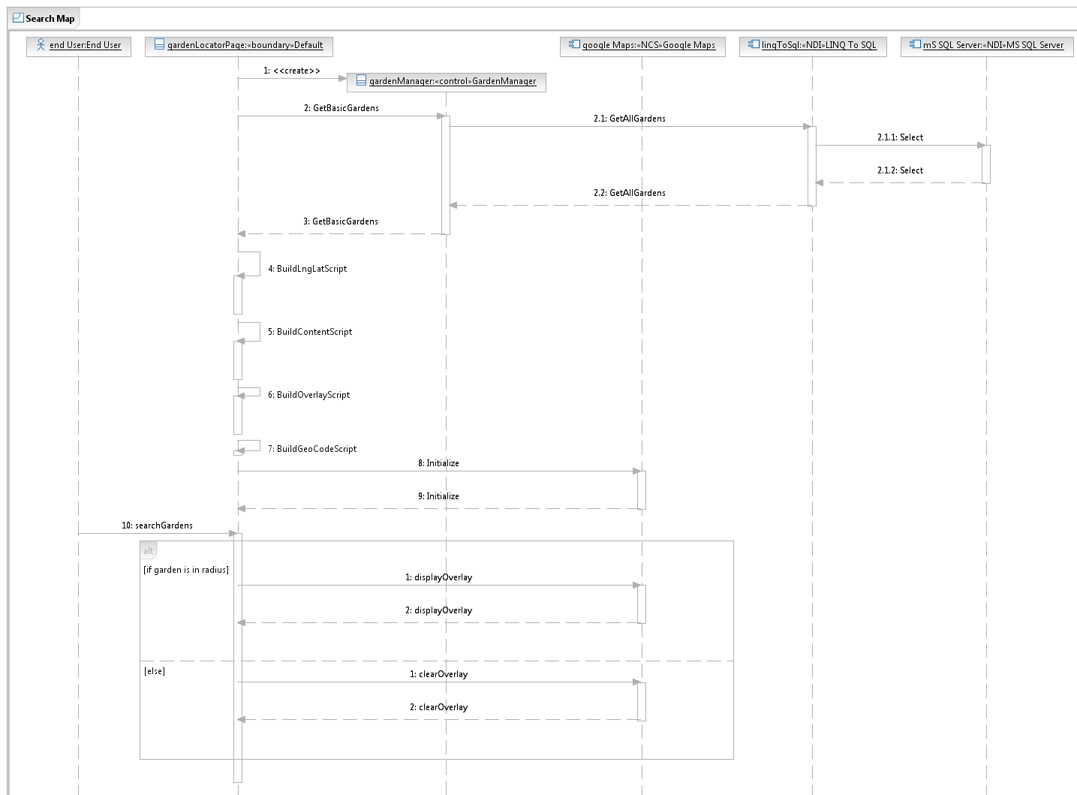
Figure 12: Search Map Sequence Diagram
The sequence diagram in Figure 13 shows how the end user can see a list of all the gardens in the database.
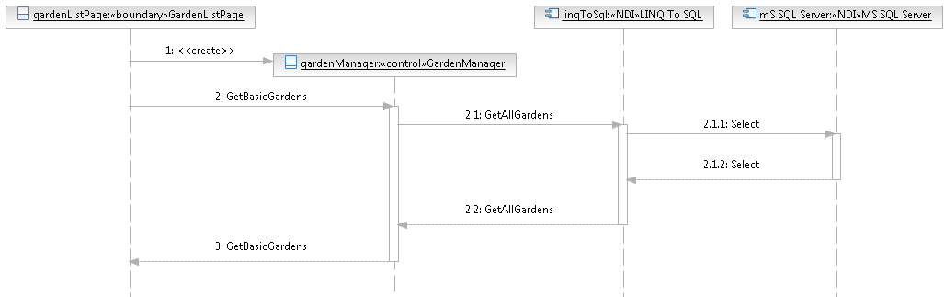
Figure 13: View All Gardens Sequence Diagram
The sequence diagram in Figure 14 shows how the database manager can add a garden to the database.
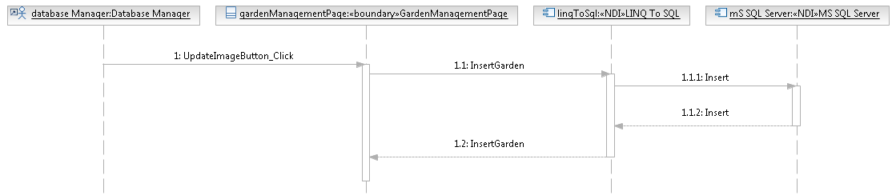
Figure 14: Add Garden Sequence Diagram
The sequence diagram in Figure 15 shows how the database manager can delete a garden from the database.
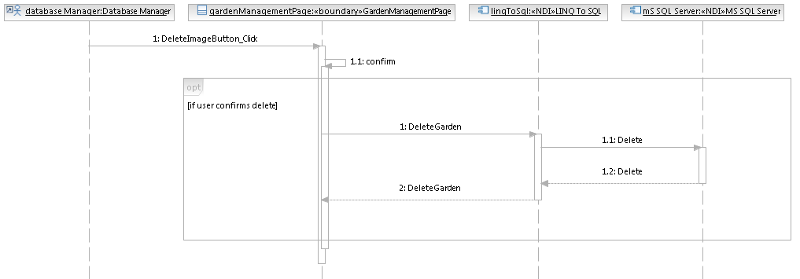
Figure 15: Delete Garden Sequence Diagram

The next sequence diagram shows how the database manager can modify the information of a garden. This diagram is shown in figure 16.

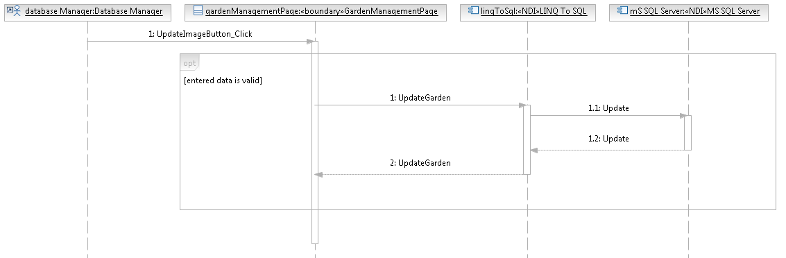
Figure 16: Modify Garden Sequence Diagram
The sequence diagram in Figure 17 shows how the database manager can search the garden table for a particular keyword.
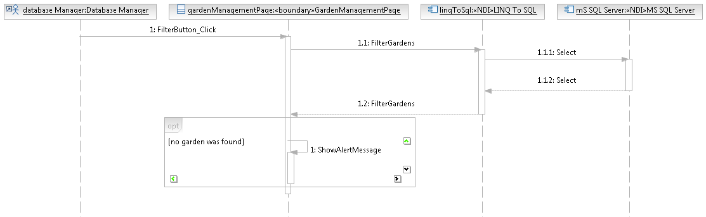
Figure 17: Search Garden Table Sequence Diagram

The sequence diagram in Figure 18 shows how the end user can download a report file of all the gardens with a limited number of columns.
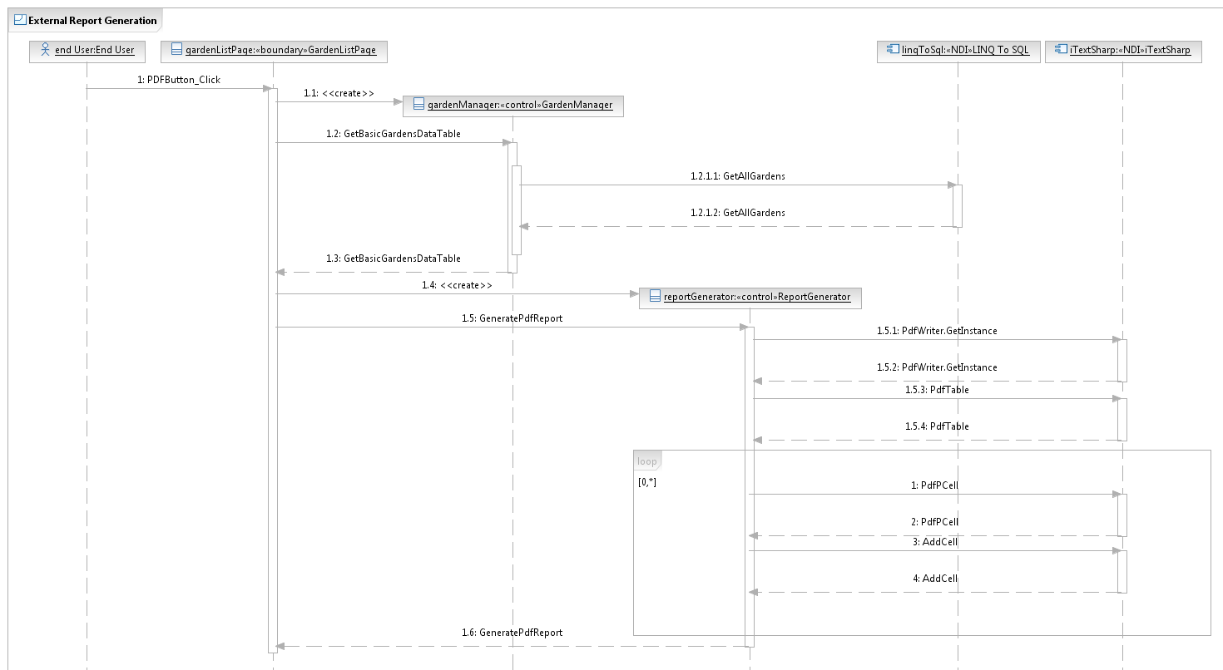
Figure 18: External Report Generation Sequence Diagram
The sequence diagram in Figure 19 shows how the database manager can download a report file of all the gardens with all the columns.
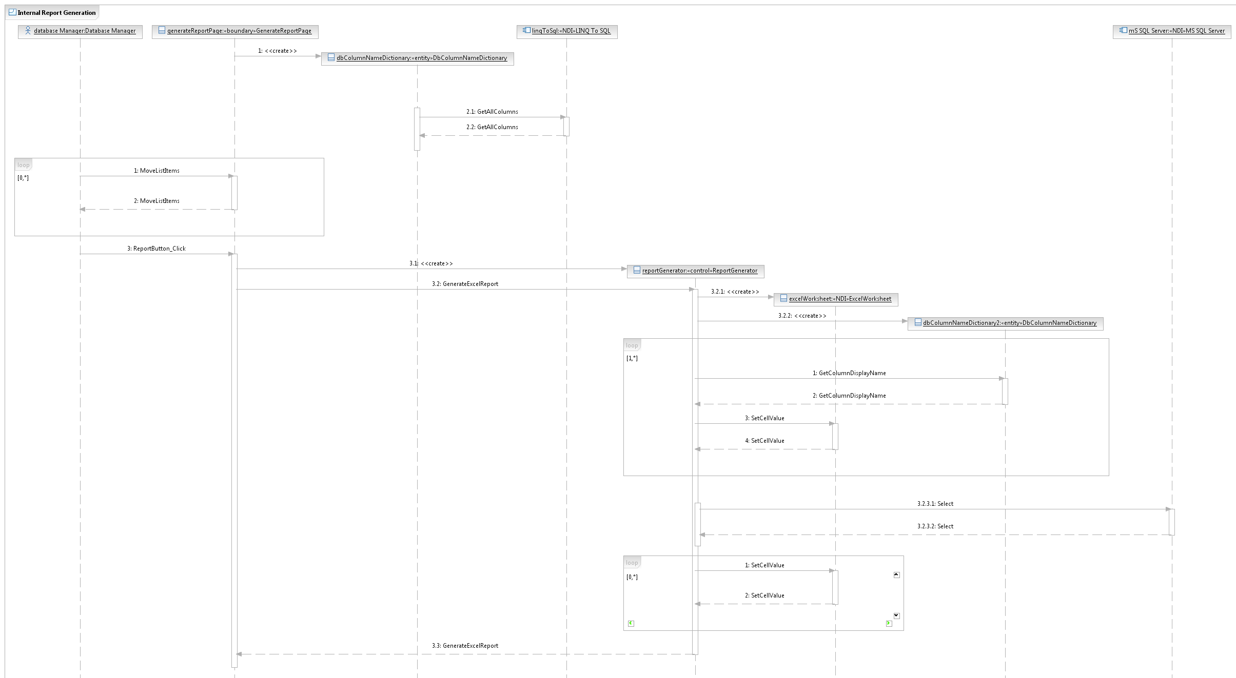
Figure 19: Internal Report Generation Sequence Diagram
The sequence diagrams in Figures 20, 21, and 22 show how the administrator can add, delete, and modify database managers.
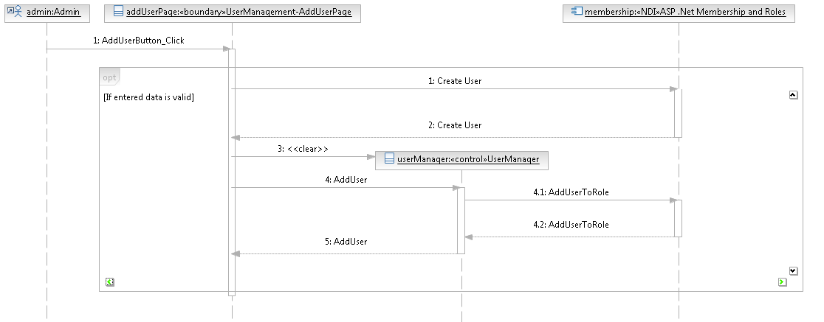
Figure 20: Add Database Manager Sequence Diagram
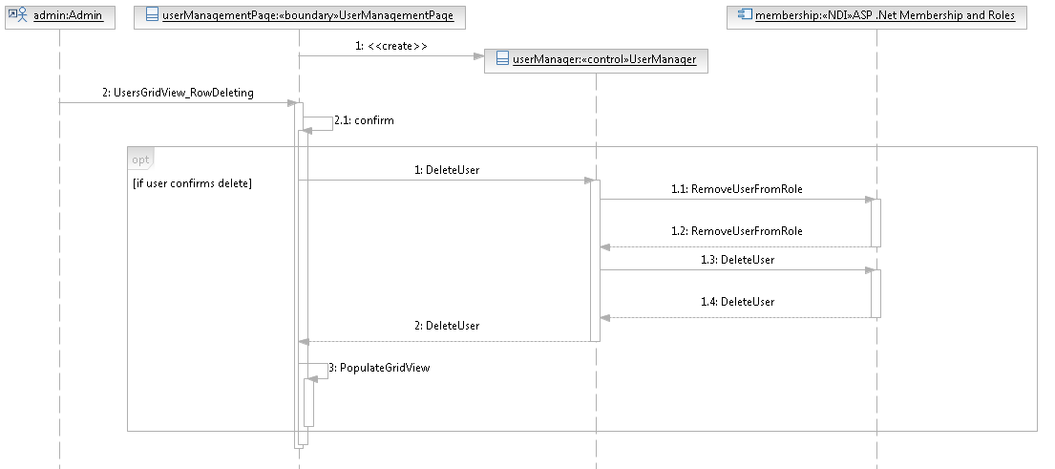
Figure 21: Delete Database Manager Sequence Diagram
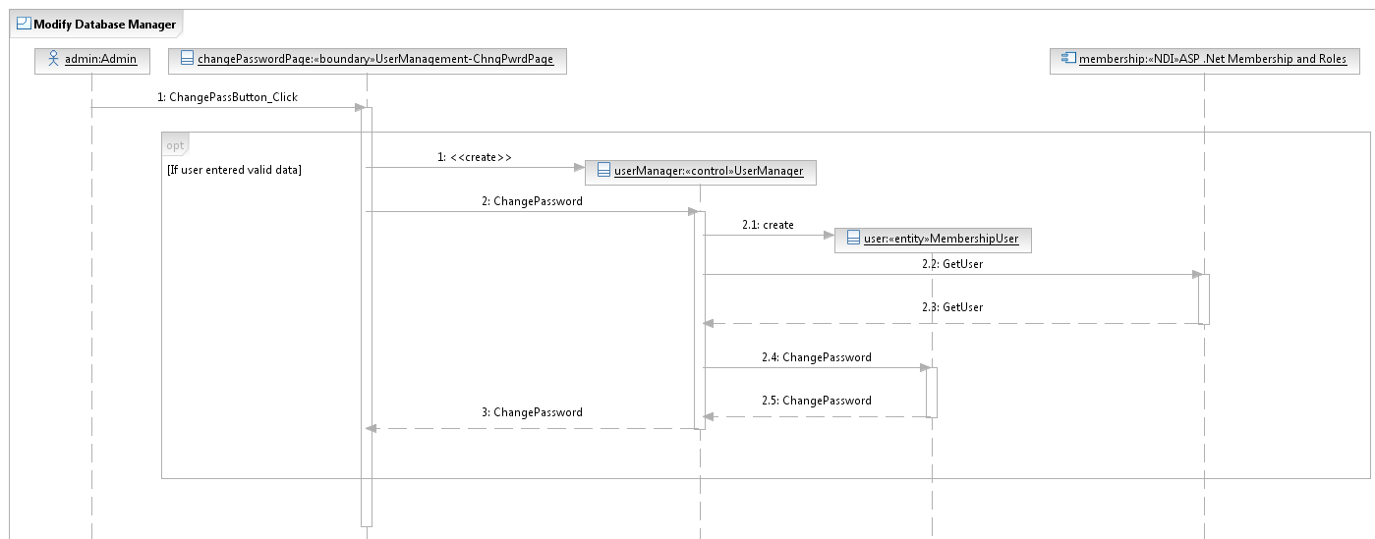
Figure 22: Modify Database Manager Sequence Diagram

Design Rationale
As depicted in Figure 5, the Garden Inventory and Locator website will have a 3-tier architecture. This architectural style makes future changes to the system easier. The three tiers, or layers, of this website are listed below:
- Presentation Tier
- Business Logic Tier
- Data Access Tier
The description of each tier can be found in Table 46.
Microsoft SQL Server will be used as the DBMS because it is the most convenient DBMS to use with ADO .NET classes; they are both manufactured by the same company and are very compatible with each other. In addition, LINQ To SQL will be used to create the necessary classes for the data access layer.
Instead of coding the user management functionality from scratch, we decided to utilize the ASP .NET Membership and Roles feature. This service of ASP .NET automatically creates database tables for storing usernames and passwords, hashes passwords for higher security, and checks users for both authentication and authorization.

Architectural Styles, Patterns and Frameworks
Table 71: Architectural Styles, Patterns, & Framework
Name | Description | Benefits, Costs, and Limitations
3-Tier Architecture | The 3-tier architecture separates the application into 3 different layers: presentation, business logic, and data access. Each layer can only communicate with the layer immediately above or below itself. | This architecture is an excellent example of separation of concerns principle: each layer is independent of the other. Therefore, any internal changes to the classes of a layer does not affect other layers. As a result, a layer can be completely replaced with a different set of classes if they have the same interface; for instance, the system can have multiple presentation layers.  The main disadvantage of this architecture is the increase in the size of the project.

Note: We tried to make the implementation comply with the 3-tier architecture as much as possible. However, because of using LINQ To SQL for facilitating the data access layer, in a few classes, there is direct connection between the presentation layer and the data access layer.

